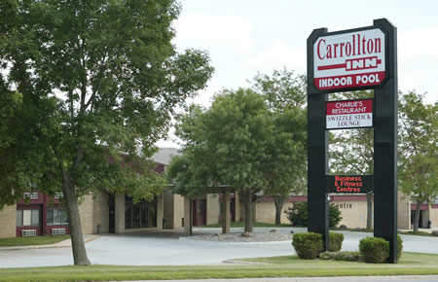

**Carrollton Inn**

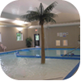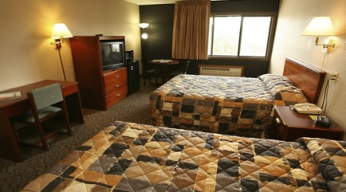1730 U.S. Hwy 71 N.

P. O. Box 828

Carroll, Iowa 51401

800-798-3535

712-792-5600

<http://www.carrolltoninn.com>

** You **must call in** to get the room discount **

Ask for Phi Theta Kappa Rooms for nights of October 6th, 7th &/or 8th

Rooms are $55/night plus 12% tax

(5% state & 7% hotel/motel tax)

Tax exempt? Bring tax exempt certificate with you!!

Rooms will be held until October 1st to get discount.

**Hotel Accommodations**

* Brand New Zero Depth Entry Pool
* Free Continental Breakfast
* Free Wireless Internet
* [Charlie's Restaurant](http://www.carrolltoninn.com/Charlies_Restaurant.html) On-Site
* [Swizzle Stick Bar & Lounge](http://www.carrolltoninn.com/swizzle.html) On-Site
* Free Morning Paper Monday- Saturday
* Fitness Centre with treadmill, exercise bike, elliptical bike and weight station
* Guest Business Centre with computer and printer access
* 24 Hour Front Desk service with fax, copier and free coffee
* Smoke Free Facility
* V.I.P. Club for frequent travelers (ask for details)

**Room Accommodations**

* Free Wireless Internet in Guest Rooms and Meeting Rooms
* Refrigerator and Microwave in Every Room
* Select Rooms Hard Wired with High Speed Internet
* Direct TV including 48 channels - 4 channels of Showtime and 4 channels of ESPN
* Free Local Calls
* Room Service from Charlie's
* Rollaways available for a small fee
* Cribs available for no charge
* All rooms are non smoking
* Sorry...pets are not allowed

**\* A Credit Card is Required at Check In.**