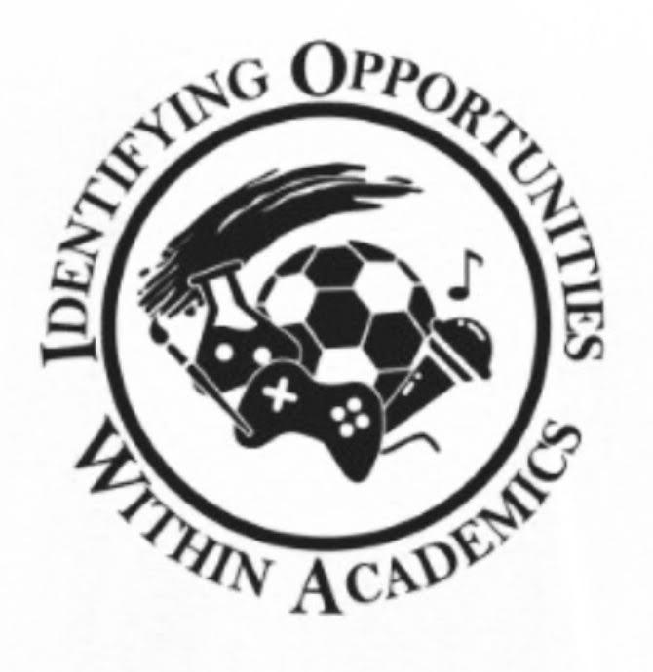

Phi Theta Kappa Iowa Regional Convention
Agenda
Thursday, February 23, 2023

12:30 PM – 1:30 PM | Registration & Marketplace  Meet the Regional Officer Candidates | Hallway near General Session Ballroom
1:30 PM – 1:40 PM | Welcoming Remarks, Roll Call, and Housekeeping | General Session Ballroom
1:40 PM – 2:15 PM | Meet the Regional Officer Candidates  *Advisor Fellowship (Off Site) | Hallway Near Ballroom
2:20 PM – 3:15 PM | First Breakout Session:  - PTK Edges, PTK Connect and more  - Advisor Fellowship (Off Site) | General Session Ballroom
3:15 PM – 4:00 PM | Second Breakout Session:  - CCSmart and Game  - College Project  - Advisor Fellowship (back at 3:45) | General Session Ballroom
4:05 PM – 5:00 PM | Third Breakout Session:  - Professional Development & Career Readiness  (presented by Alumni chapter)  - Advisor Meeting | General Session Ballroom  TBA
5:10 PM – 6:00 PM | Regional Officer Candidate Speeches and Q/A  Voting Procedures | General Session Ballroom
6:00 PM – 6:10 PM | Chapter Deliberation and Voting | TBA
6:10 PM – 7:00 PM | Buffett Dinner | Serve in the hallways outside of the General Session Ballroom
7:00 PM – 9:00 PM | Fellowship with Regional Officers  Alumni Business Meeting | General Session Ballroom

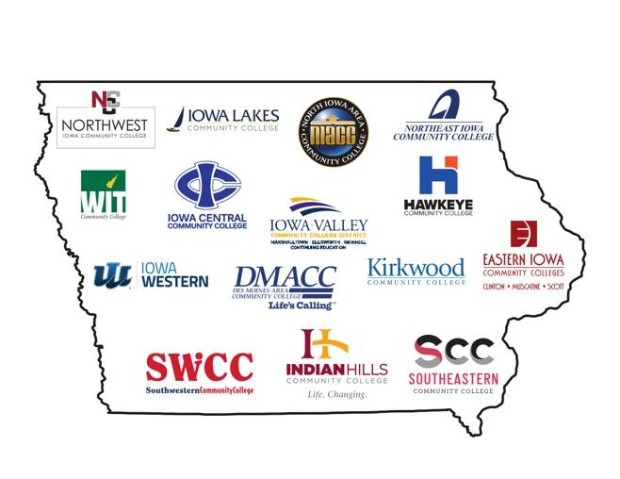
Phi Theta Kappa: Iowa Regional Convention
Agenda
Friday, February 24, 2023

7:00 AM – 9:00 AM | Registration  Marketplace  Breakfast for Attendees | Hallway near General Session  General Session Ballroom  Serve in the Hallway outside of the Ballroom
8:00 AM – 8:55 AM | Executive Board Meeting | Guest room
9:00 AM – 9:30 AM | Roll Call Skits | General Session Ballroom
9:30 AM – 9:40 AM | Housekeeping and Agenda | General Session Ballroom
9:40 AM – 10:30 AM | Fourth Breakout Session:  - 5-Star Chapter Development  - Honors in Action- Ms. Pattie Van Atter | General Session Ballroom
10:30 AM – 11:00 AM | Fifth Breakout Session  Networking Activity with the Regional Officers | General Session Ballroom
10:40 AM – 11:30 AM | Advisors Meeting | TBA
11:00 AM – 12:00 PM | College Fair | Hallway near General Session
12:00 PM – 1:10 PM | Lunch  Keynote Speaker- Dr. Joseph Liesen  Esports @Culver-Stockton College:  More than just Games | General Session Ballroom
1:10 PM – 1:25 PM | IA Region Alumni Chapter Update | General Session Ballroom
1:25 PM – 1:40 PM | IA Region Update - Sima Dabir | General Session Ballroom
1:40 PM -1:55PM | Headquarters Update - Pattie Van Atter | General Session Ballroom
1:55 PM -2:05 PM | Break – Ceremony Prep | General Session Ballroom
2:05PM – 2:45 PM | Regional Awards Ceremony & Recognition | General Session Ballroom
2:45 PM – 3:05 PM | 2022-23 Regional Officers - Farewell Speeches | General Session Ballroom
3:05 PM-3:15 PM | Break – New RO Installation Prep | General Session Ballroom
3:15 PM – 3:30 PM | Installation of 2023-24 Regional Officers | General Session Ballroom
3:30 PM – 4:00 PM | Farewell  Group Photos | General Session Ballroom

